**EXP NO 4: CREATE A SIMPLE CLOUD SOFTWARE APPLICATION FOR LIBRARY BOOK RESERVATION SYSTEM USING FOR SIMATS USING ANY CLOUD TO DEMOSTRATE SAAS**

DATE:

**AIM:** CREATE A SIMPLE CLOUD SOFTWARE APPLICATION FOR LIBRARY BOOK RESERVATION SYSTEM USING FOR SIMATS USING ANY CLOUD TO DEMOSTRATE SAAS PROCEDURE**:**

STEP 1: GO TO ZOHO.COM.

STEP 2: LOG INTO THE ZOHO.COM.

STEP 3: SELECT ONE APPLICATION STEP.

STEP 4: ENTER APPLICATION NAME AS FLIGHT RESERVATION SYSTEM.

STEP 5: CREATED NEW APPLICATION FLIGHT RESERVATION SYSTEM.

STEP 6: SELECT ONE FORM.

STEP 7: THE SOFTWARE HAS BEEN CREATED.

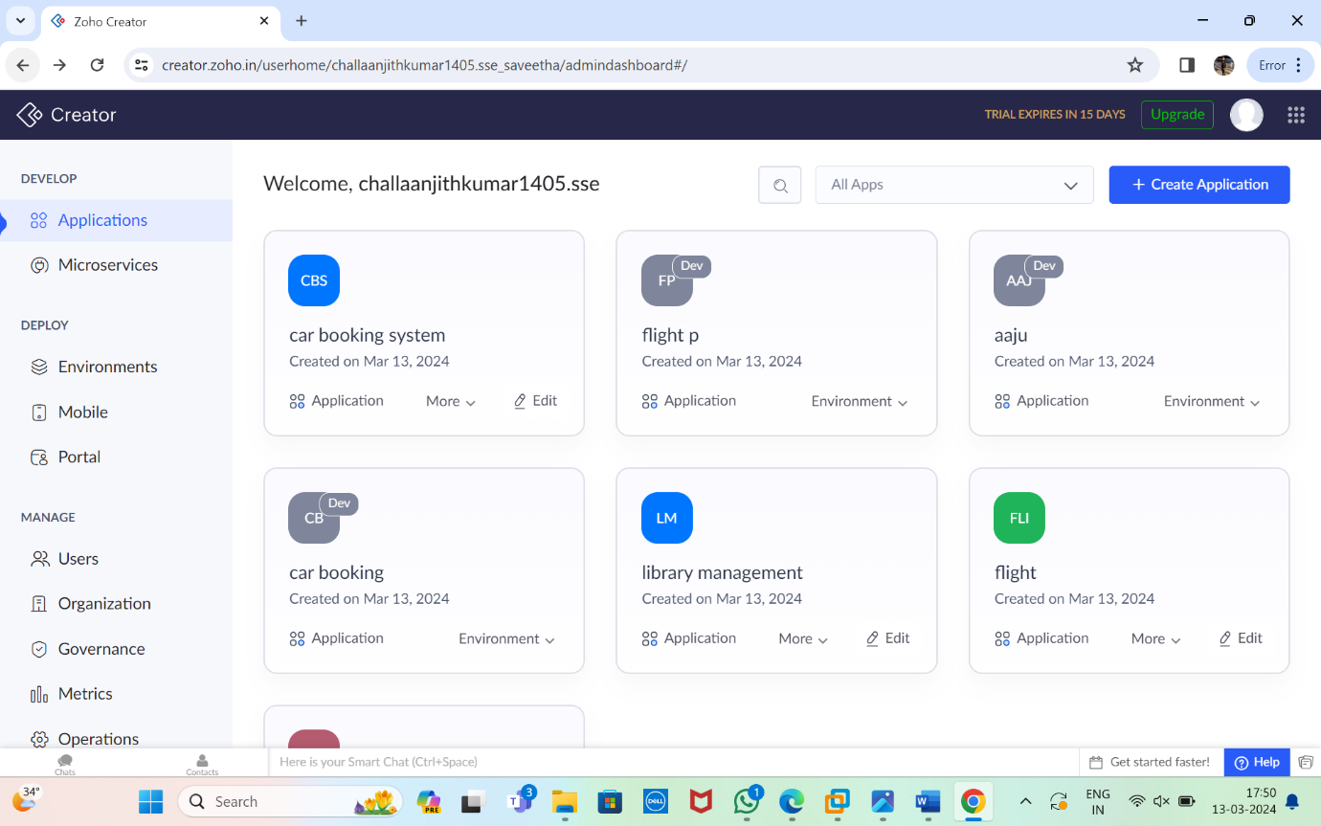

**We have to create the application for data**.

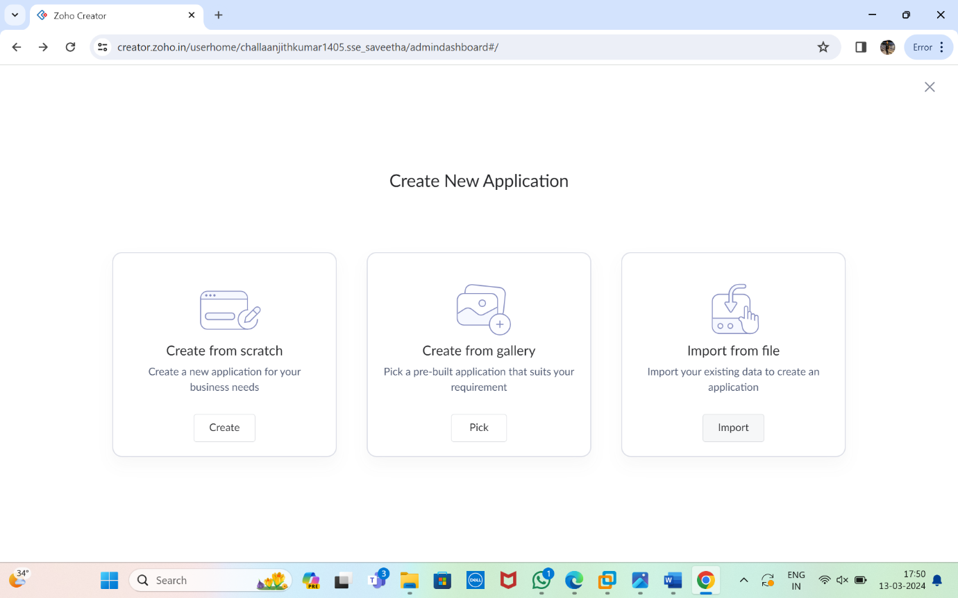

**Then again create application with scratch/gallery/import from file.**

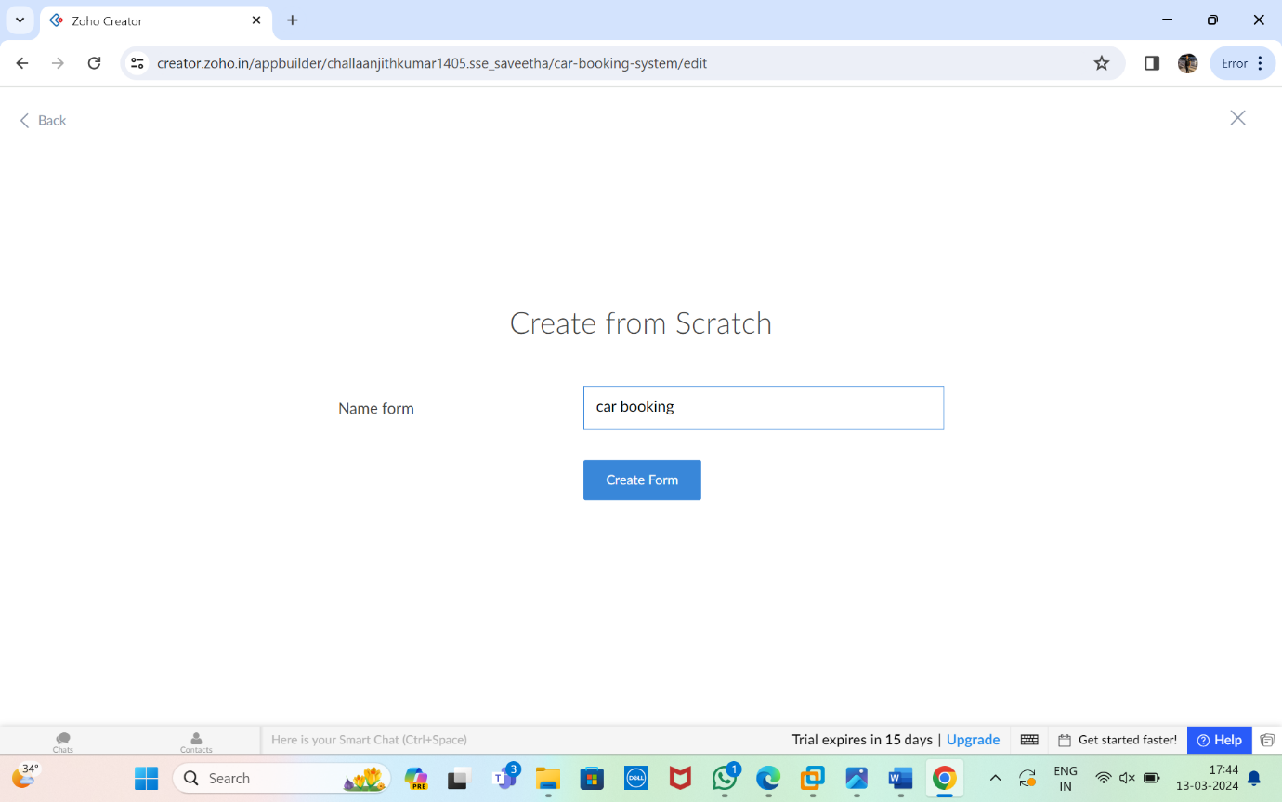

**I have chosen with create from scratch and giving application name**

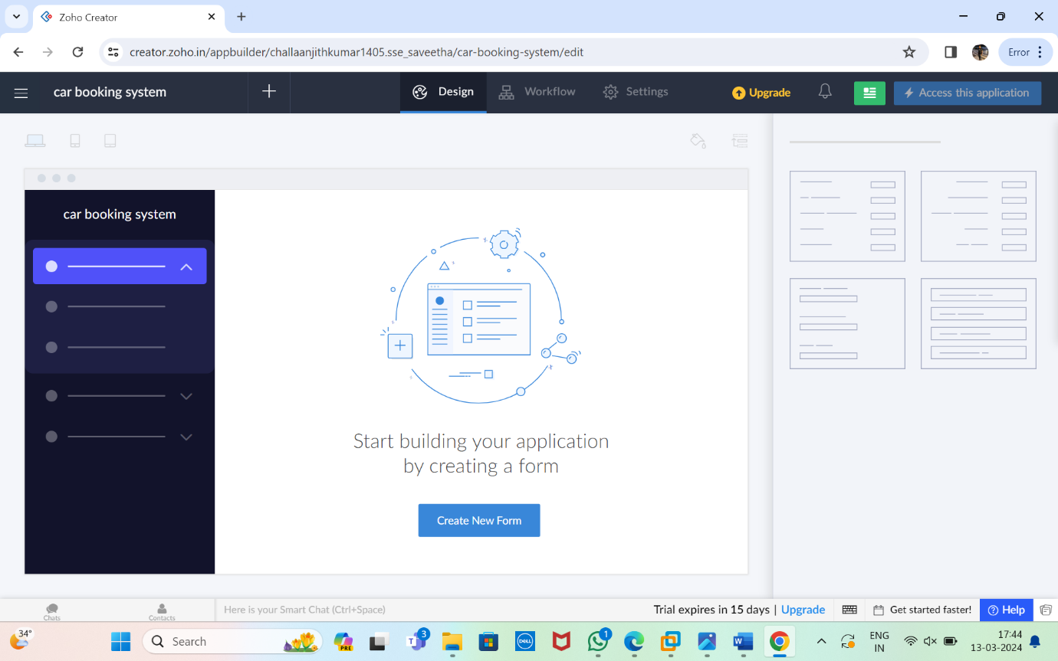

**Then we have to create a new form .**

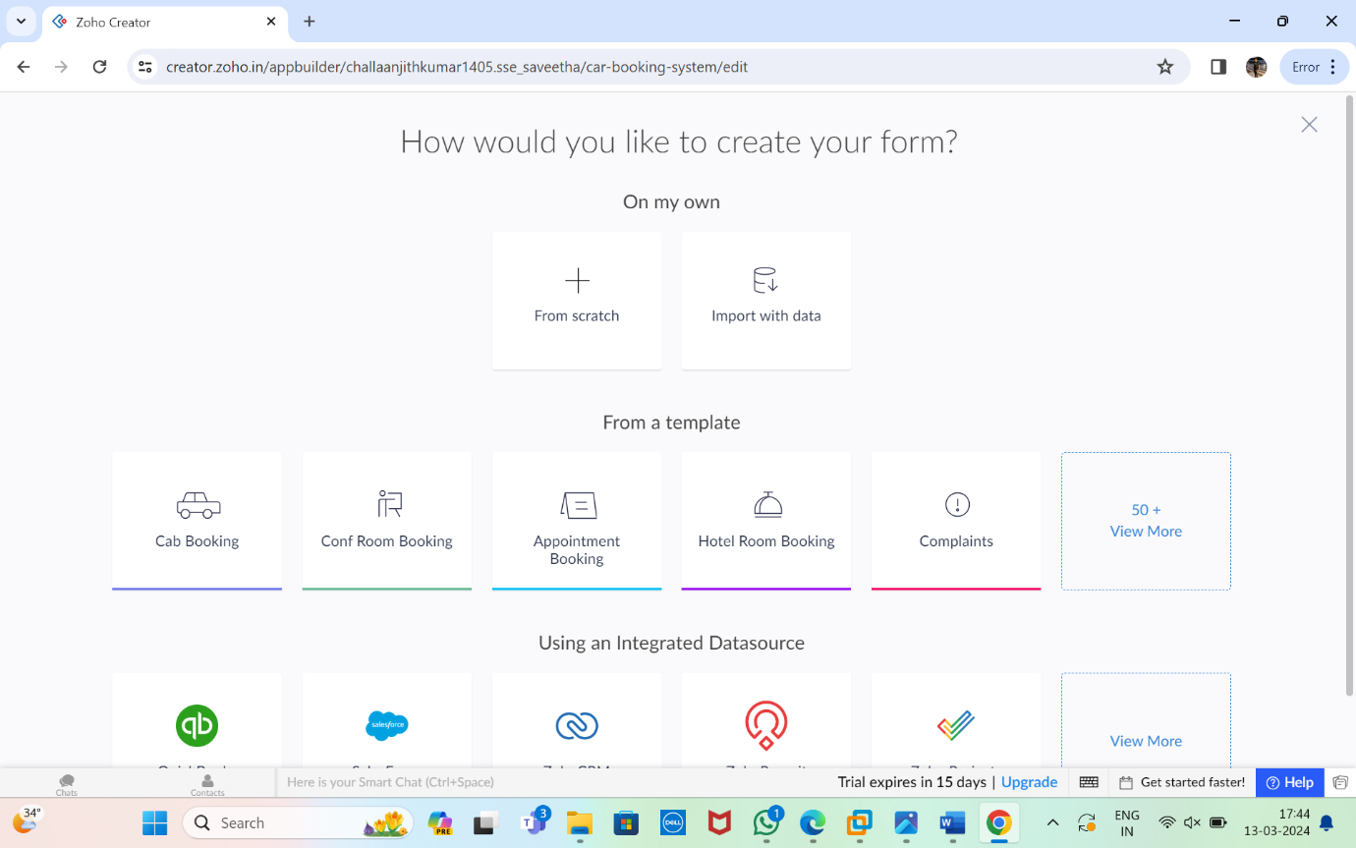

**We have to create the new form from scratch**.



**Give the algorithm what the data you want.**

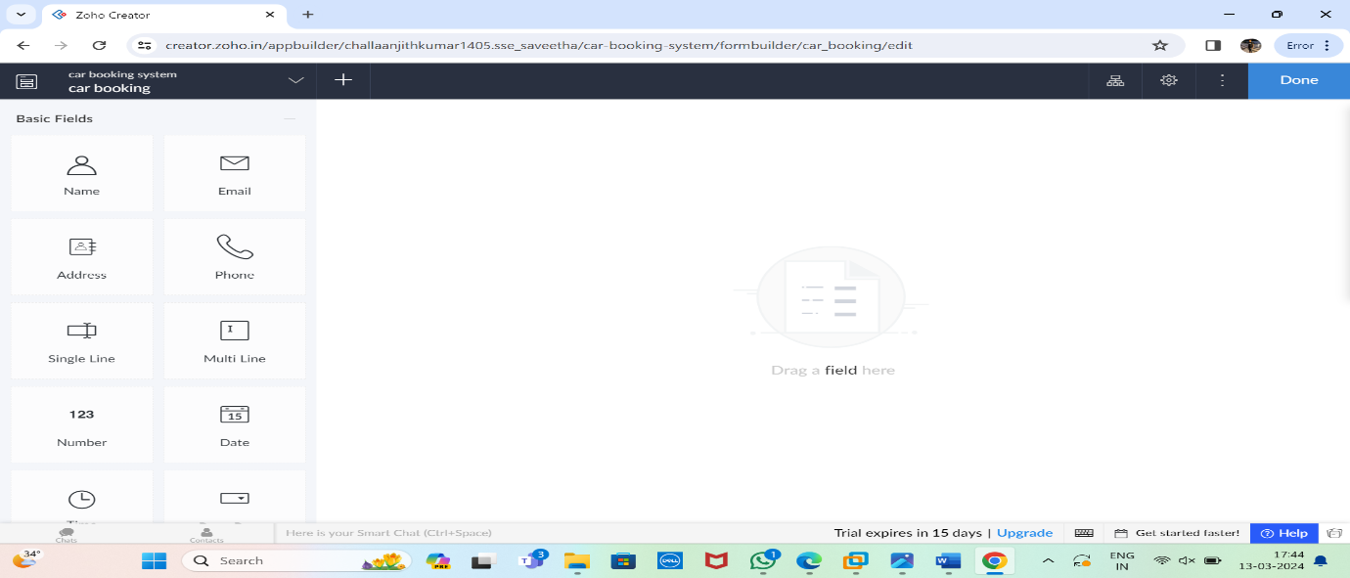

**To implement the passenger details we have to enter the data of the passenger.**

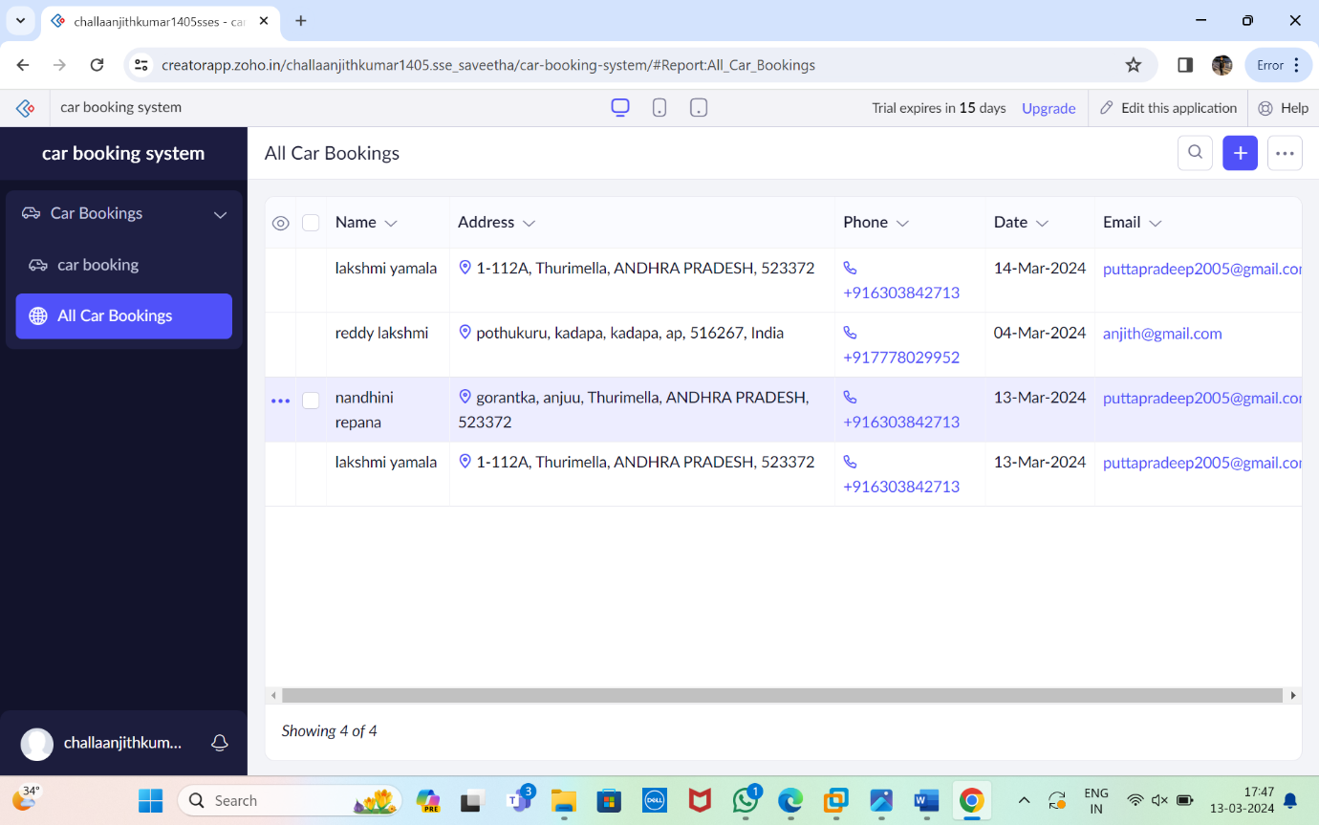

**Give the details for 4 to 5 members of the passenger details.**